**Open-loop Transfer function verification test.**

In this test, the aim is verifying the analytically calculated transfer function by using a reliable software tool. For that purpose, we simply created a “Average Switch model” of the CCM flyback converter in the matlab.

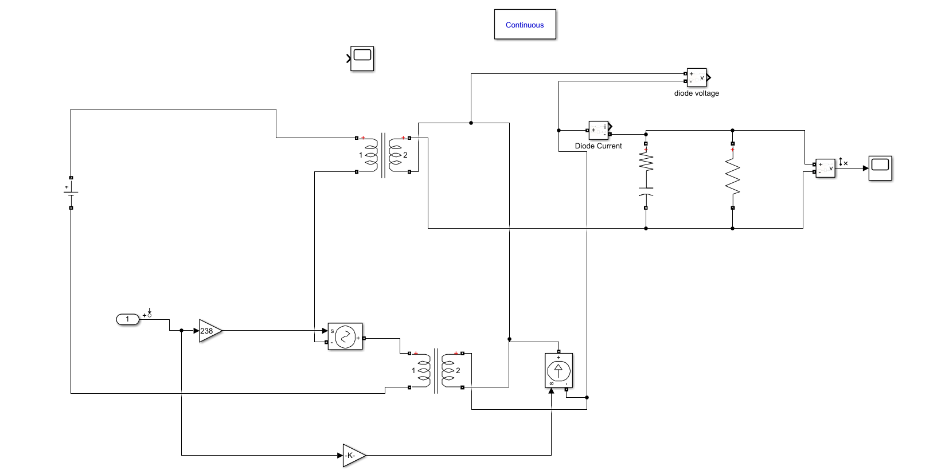

FigureXX: Average switch model of flyback converter.

By using that circuit, we just linearize the switch network which includes diode and mosfet however, there are still non-idealities in the circuit because we don’t exclude input voltage in that circuit. However, linearizing those non-linearities would become much easier compared to original circuit because linearizing duty cycle is much more harder.

Therefore, as we can understand we simply use linearizing tool of the matlab to extract bode plot and transfer function of the open-loop system.

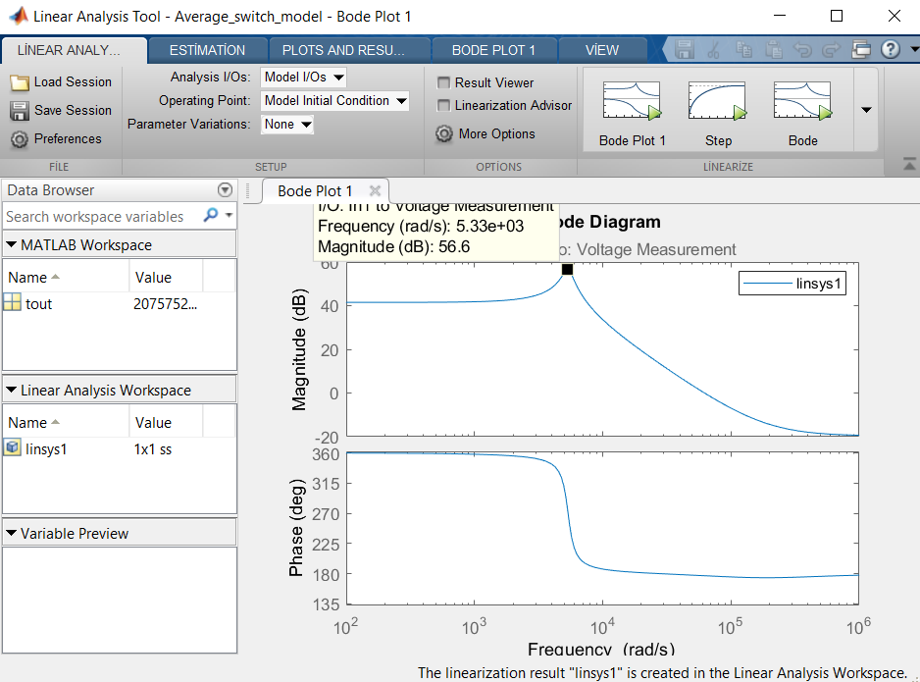

FigureXX: Bode plot of average switch network When Vin=36 Volt.

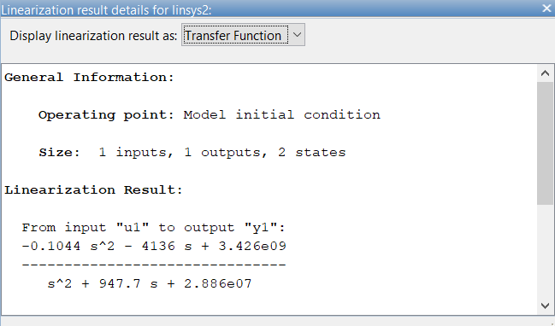

FigureXX: Extraction of transfer function from linearization tool.

As can be seen from the figures Open-loop transfer functions are closely match with the analytical resuls.